NAMA : RAIF FAWWAZDZAKY

NIM : 1202200054

KELAS : SI4407

**[TAMPILAN]**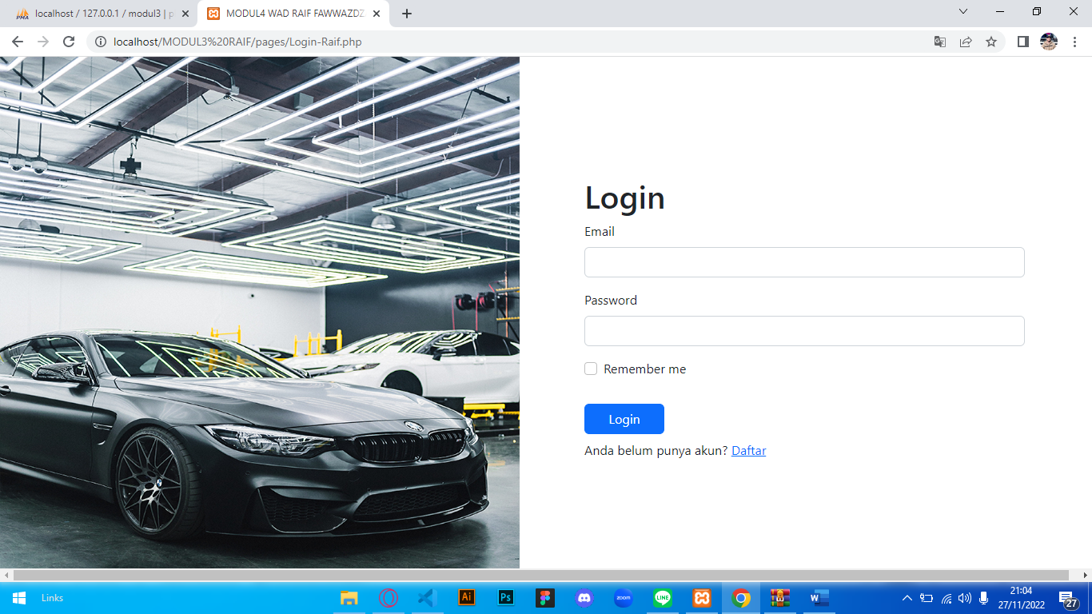

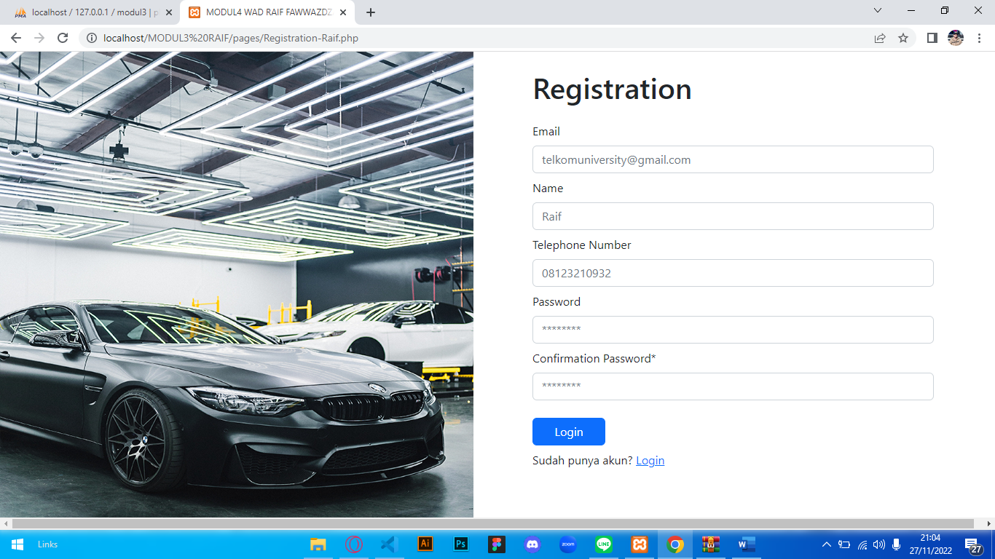

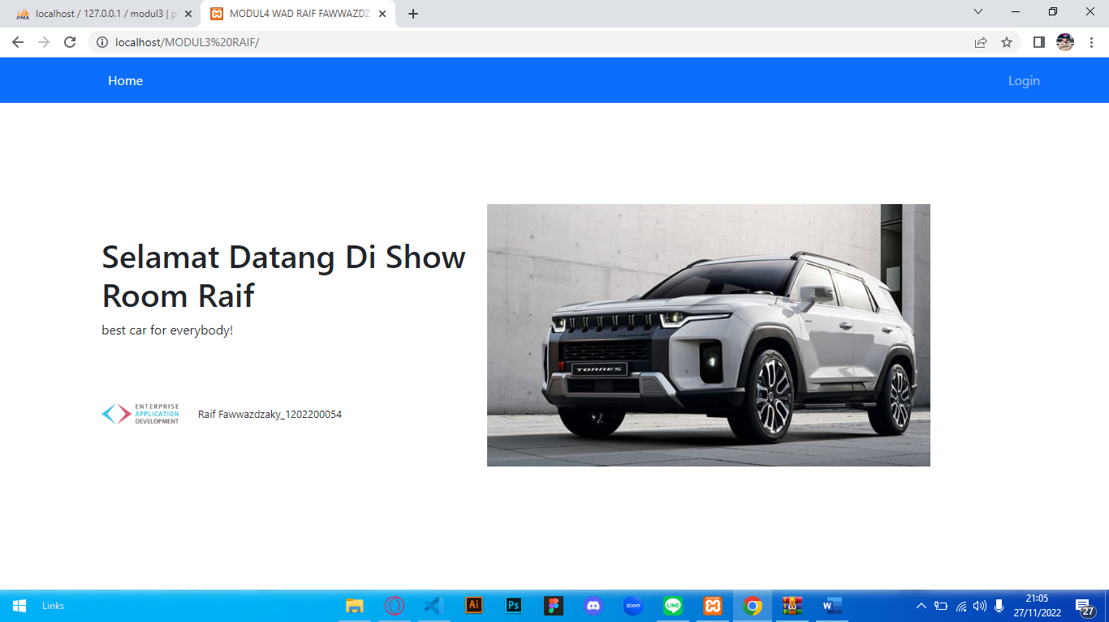

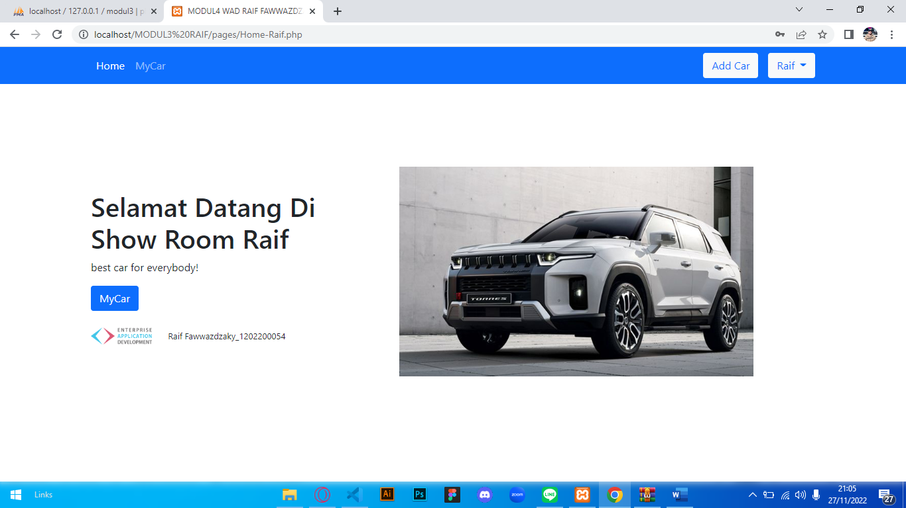

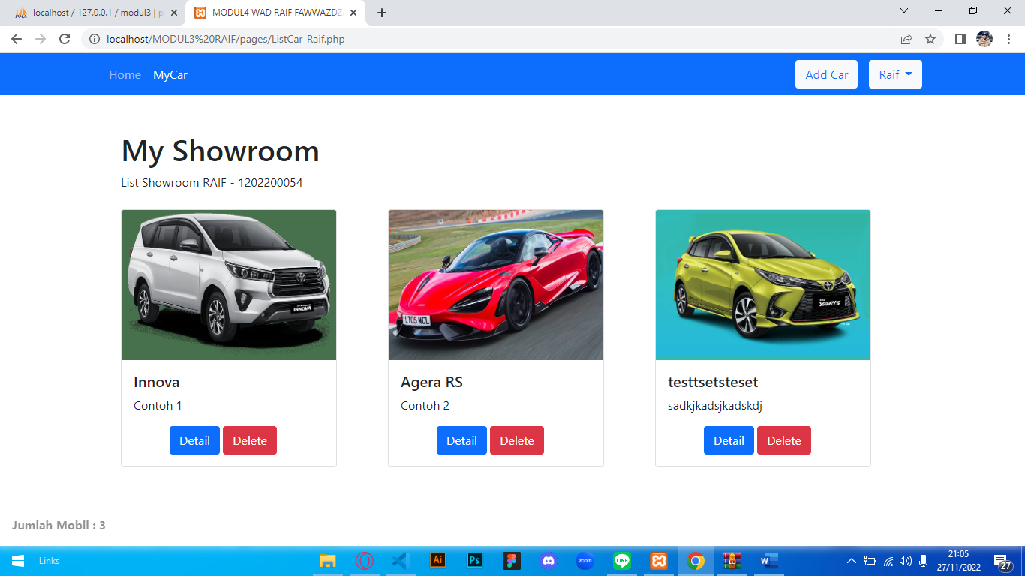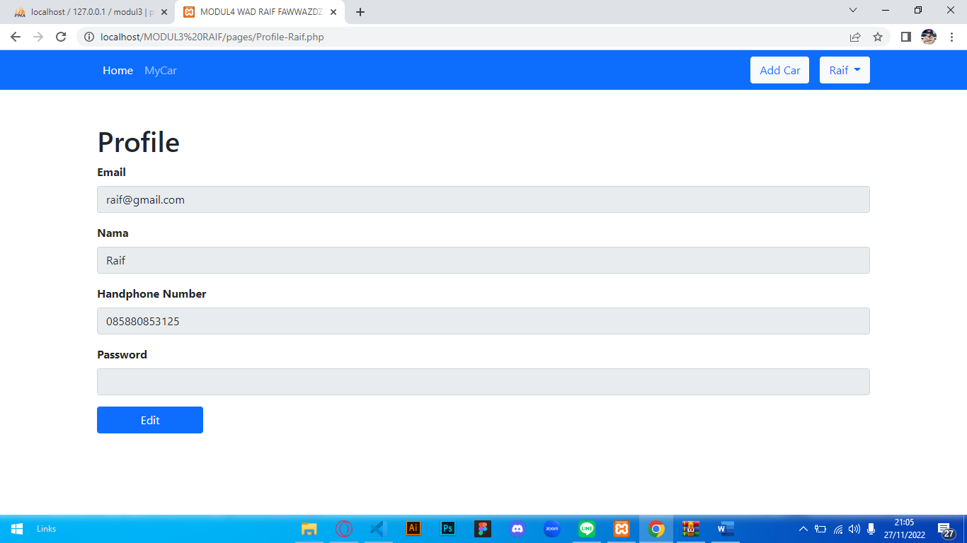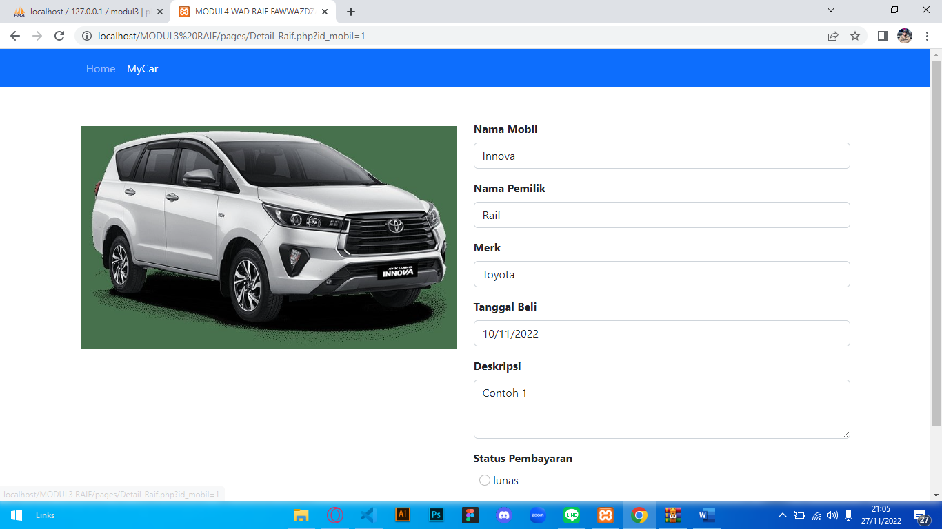

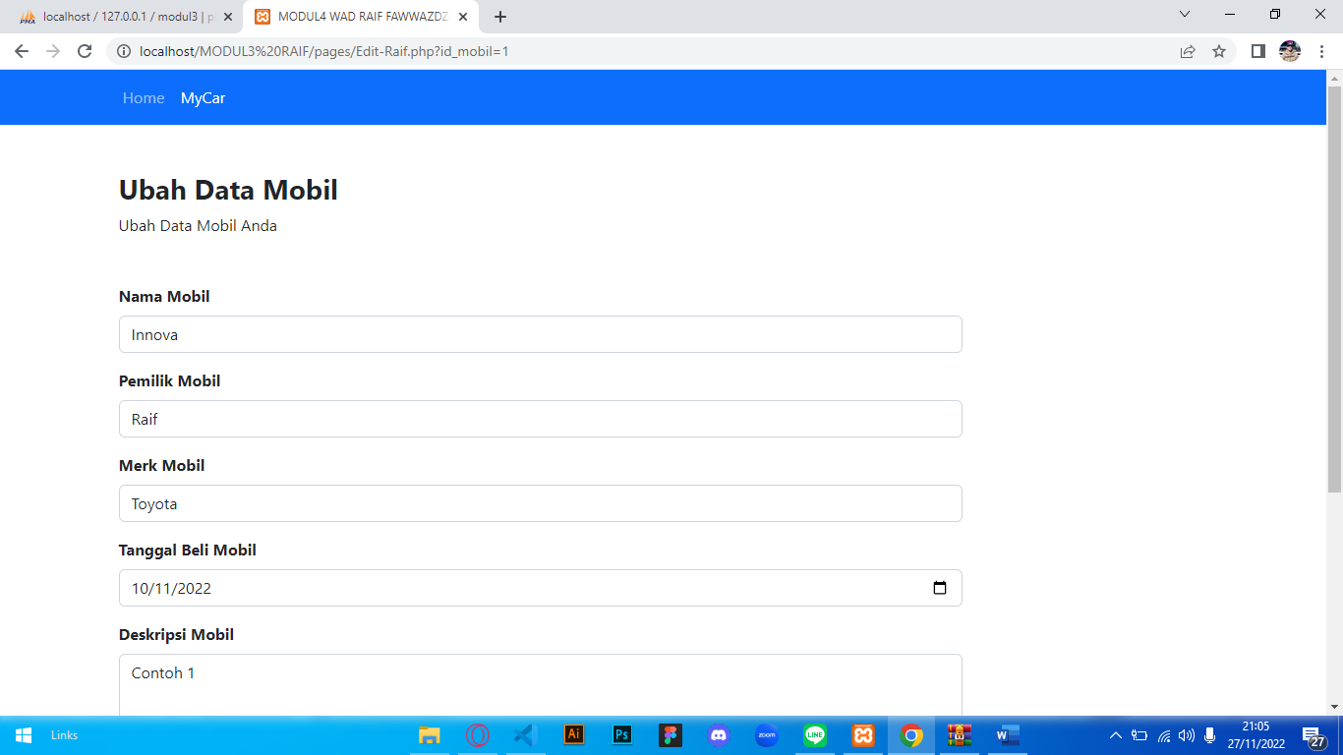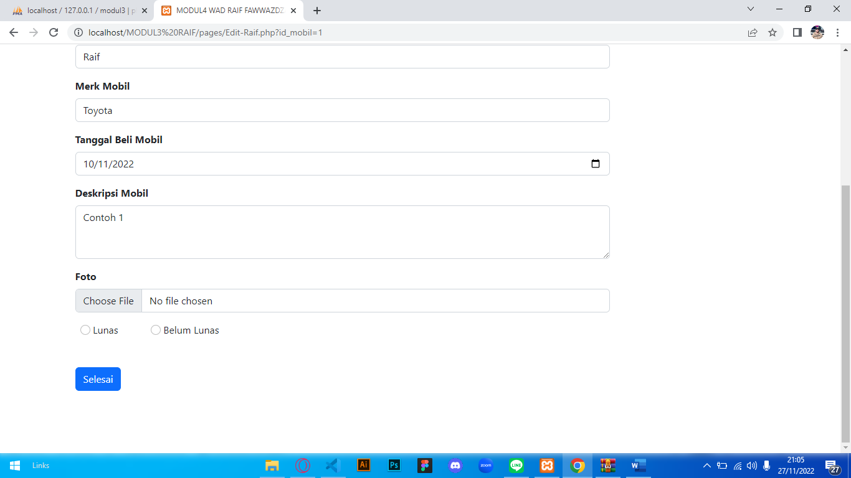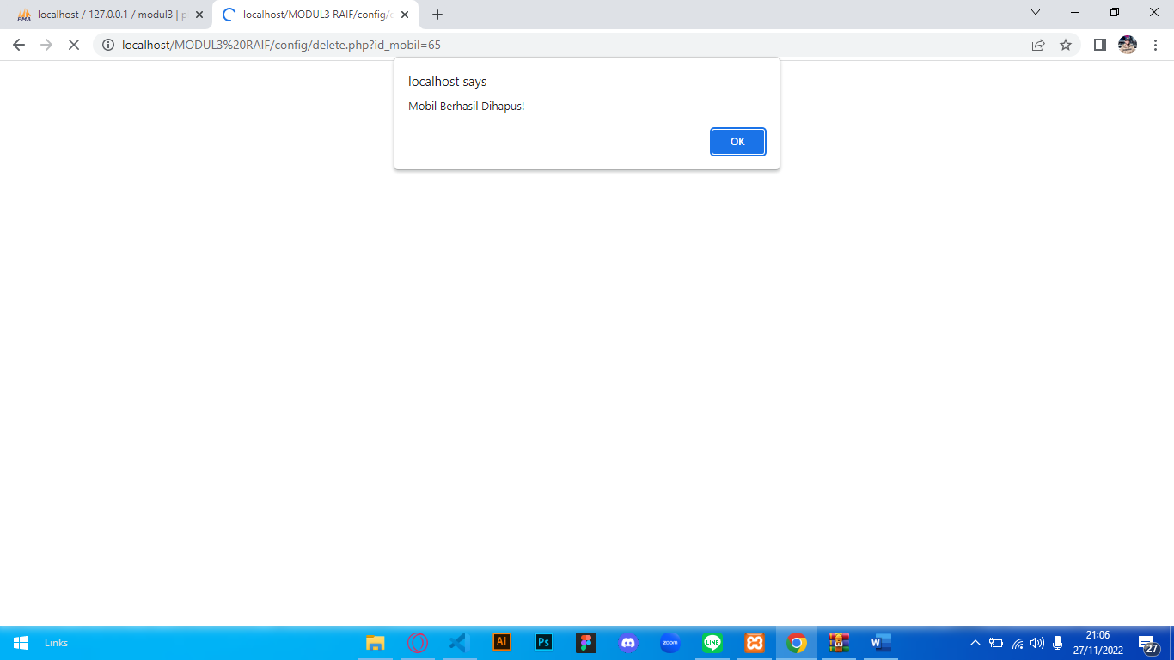

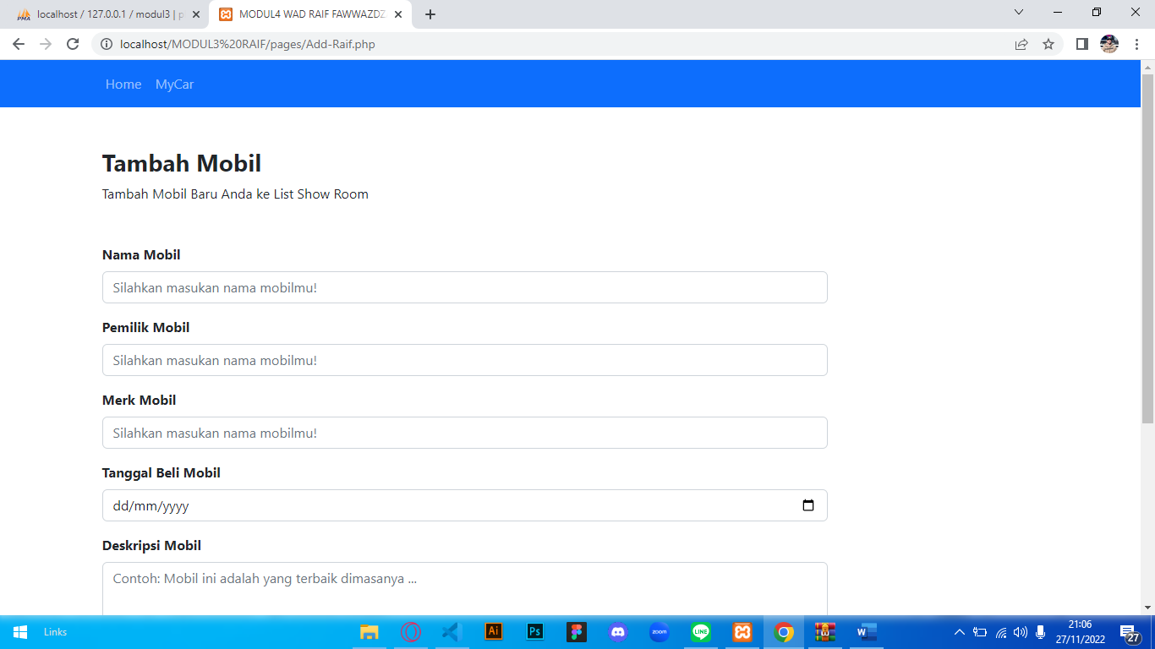

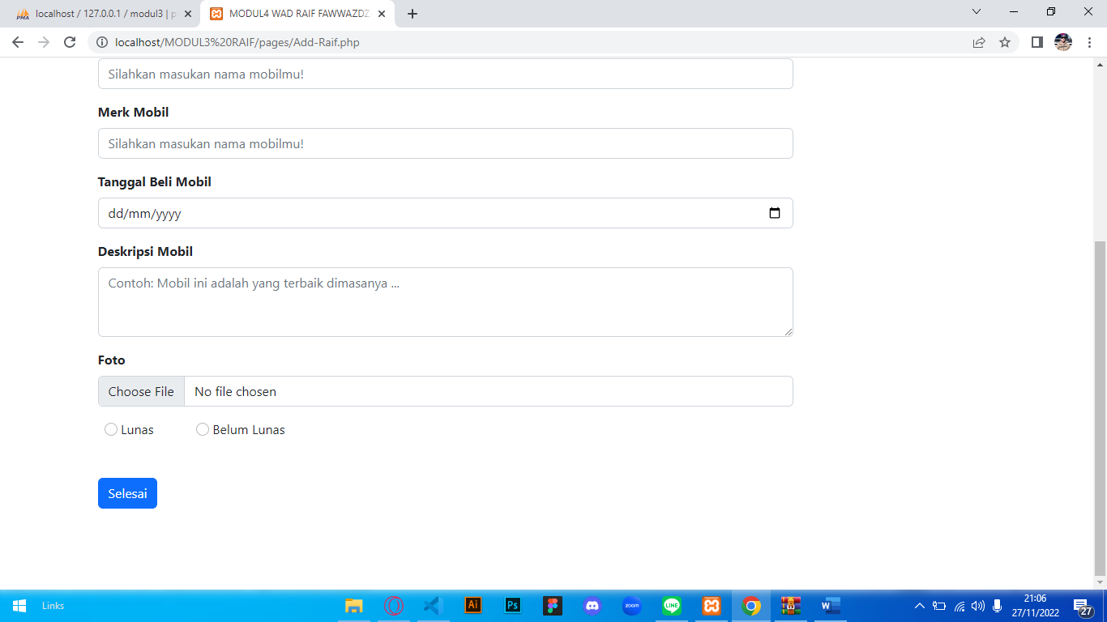

**[SOURCE CODE]**

Connect.php

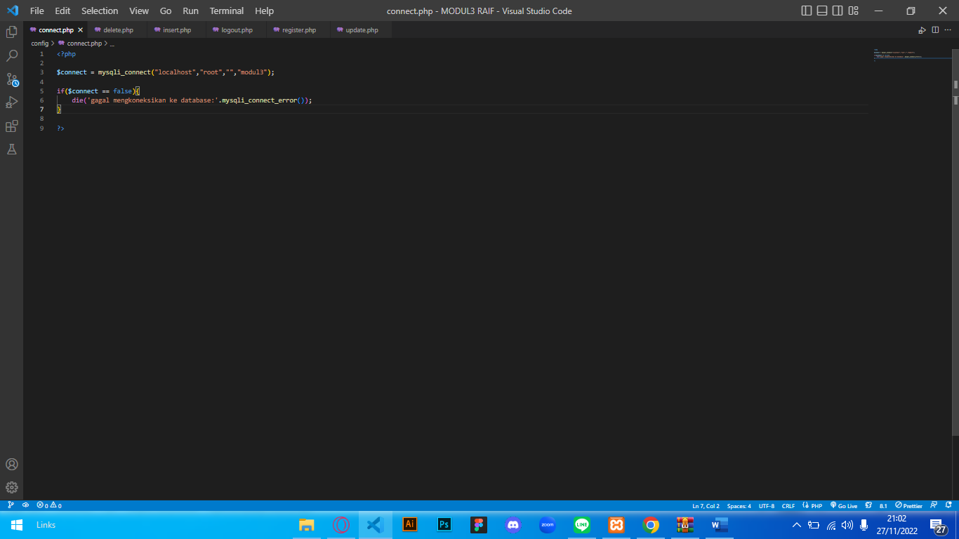

Delete.php

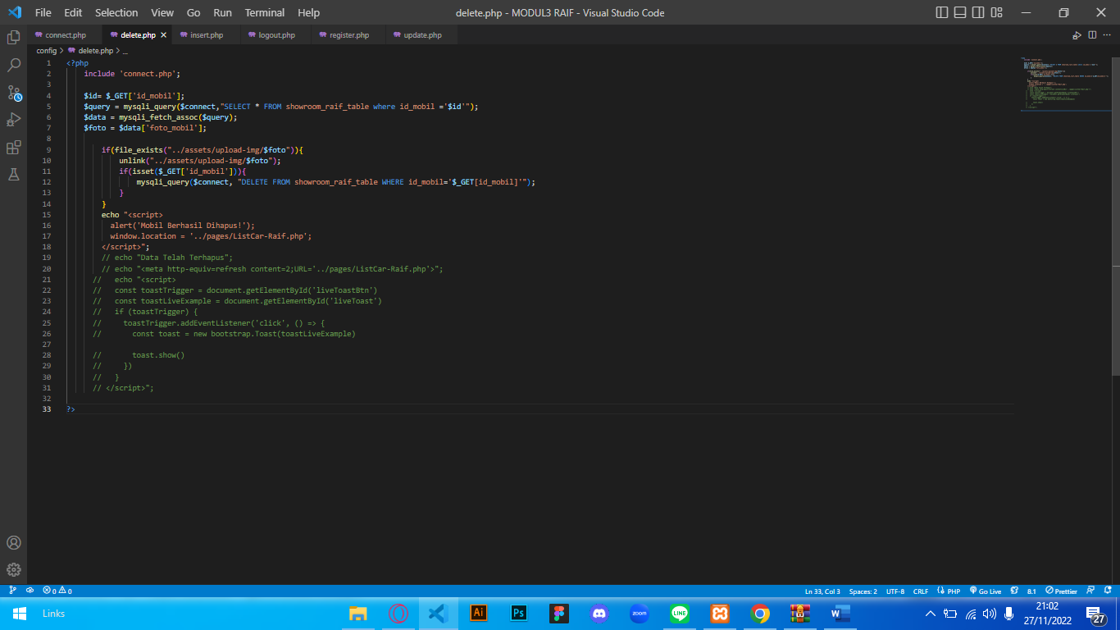

Insert.php

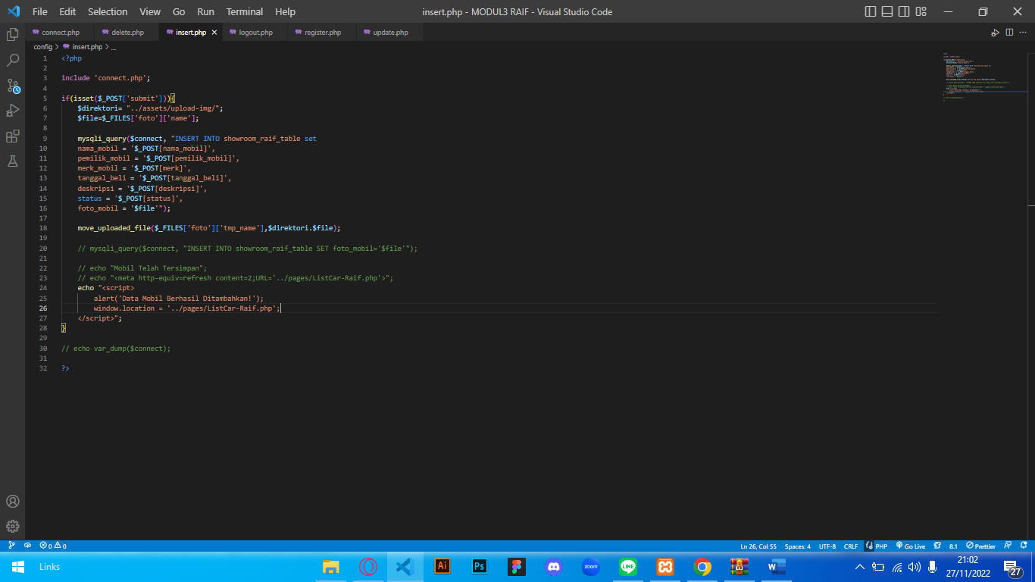

Logout.php

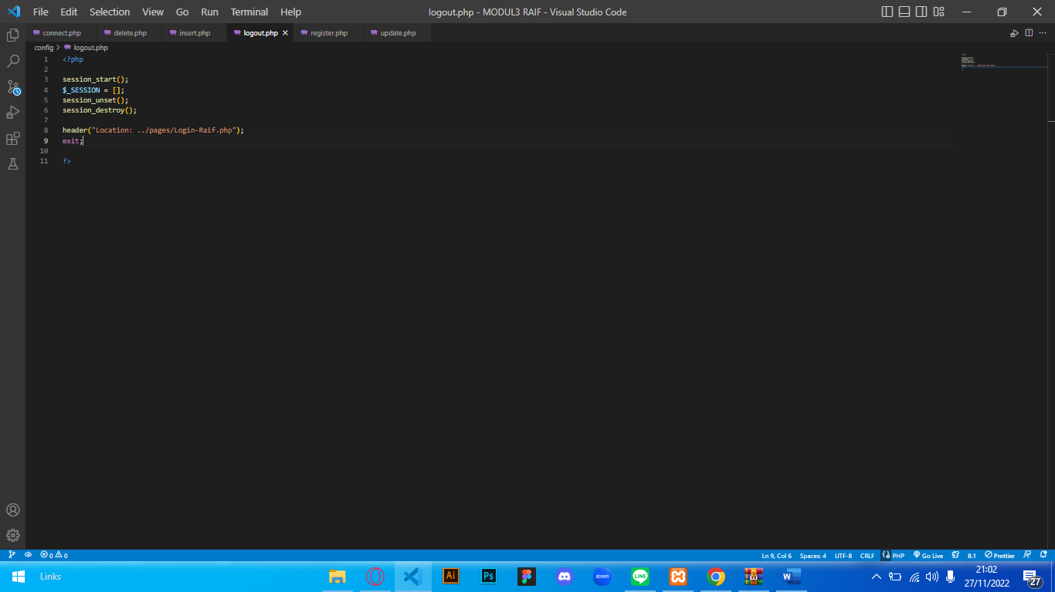

Register.php

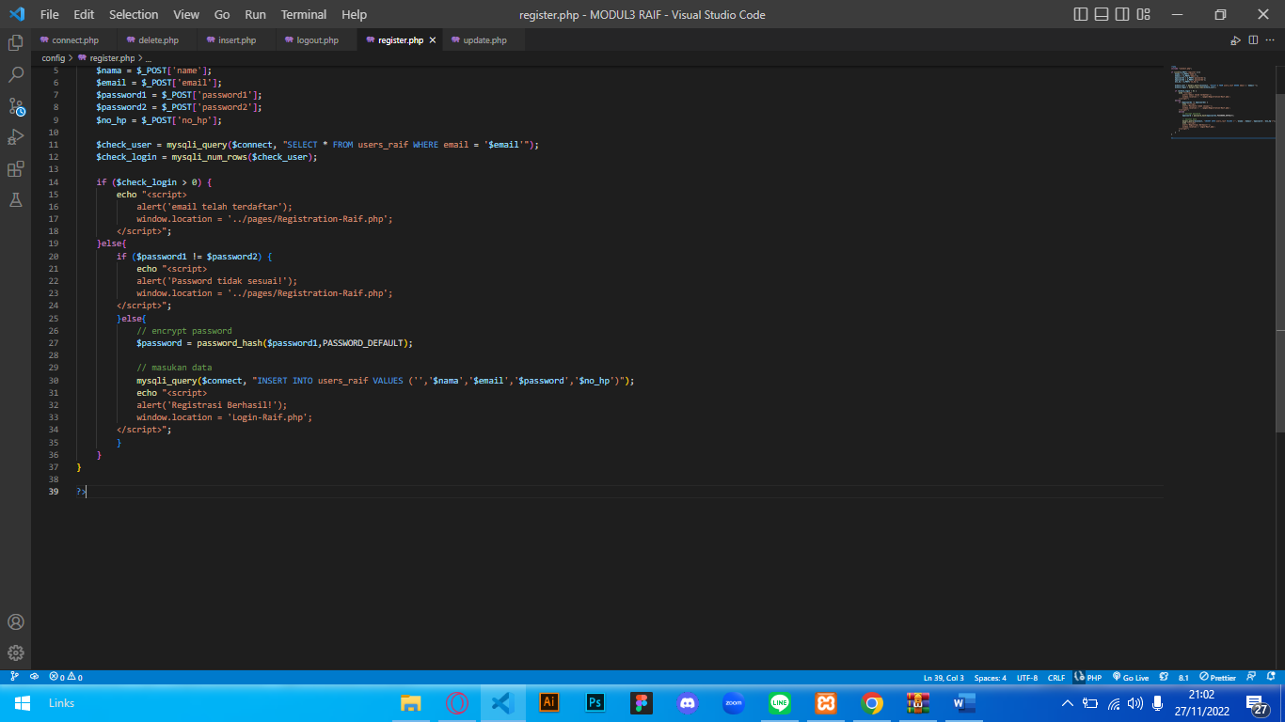

Update.php

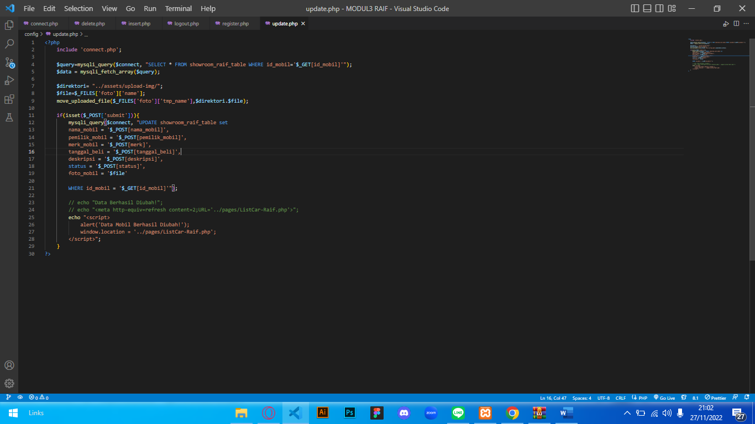

Add-Raif.php

<?php

session_start();

if(!isset($_SESSION["login"])) {

  header("Location: Login-Raif.php");

  exit;

}

?>

<html lang="en">

    <!DOCTYPE html>

<head>

    <meta charset="UTF-8">

    <meta http-equiv="X-UA-Compatible" content="IE=edge">

    <meta name="viewport" content="width=device-width, initial-scale=1.0">

    <title>MODUL4 WAD RAIF FAWWAZDZAKY</title>

    <link rel="stylesheet" href="../bootstrap/css/bootstrap.css">

    <link rel="stylesheet" href="../bootstrap/css/bootstrap.min.css">

    <link rel="stylesheet" href="../bootstrap/css/style.css">

    <link rel="stylesheet" href="https://cdnjs.cloudflare.com/ajax/libs/font-awesome/6.2.0/css/all.min.css">

</head>

<body>

<!-- nabvar     -->

<nav class="navbar navbar-expand-lg navbar-dark bg-primary">

  <div class="container">

    <button class="navbar-toggler" type="button" data-bs-toggle="collapse" data-bs-target="#navbarNavAltMarkup" aria-controls="navbarNavAltMarkup" aria-expanded="false" aria-label="Toggle navigation">

      <span class="navbar-toggler-icon"></span>

    </button>

    <div class="collapse navbar-collapse" id="navbarNavAltMarkup">

      <div class="navbar-nav">

        <a class="nav-link" aria-current="page" href="../index.php">Home</a>

        <a class="nav-link" href="ListCar-Raif.php">MyCar</a>

      </div>

    </div>

  </div>

</nav>

<!-- navbar akhir -->

<!-- form -->

<div class="container mt-5 px-3" style="margin-bottom:100px">

    <h3 class="fw-bold">Tambah Mobil</h3>

    <p>Tambah Mobil Baru Anda ke List Show Room</p>

        <form action="../config/insert.php" method="POST" class="mt-5" style="margin-right:250px" enctype="multipart/form-data">

            <!-- NAMA MOBIL -->

            <div class="mb-3">

                <label for="nama_mobil" class="form-label fw-bold">Nama Mobil</label>

                <input type="text" class="form-control" name="nama_mobil" placeholder="Silahkan masukan nama mobilmu!">

            </div>

            <!-- NAMA MOBIL -->

            <div class="mb-3">

                <label for="pemilik_mobil" class="form-label fw-bold">Pemilik Mobil</label>

                <input type="text" class="form-control" name="pemilik_mobil" placeholder="Silahkan masukan nama mobilmu!">

            </div>

            <!-- MERK MOBIL -->

            <div class="mb-3">

                <label for="merk" class="form-label fw-bold">Merk Mobil</label>

                <input type="text" class="form-control" name="merk" placeholder="Silahkan masukan nama mobilmu!">

            </div>

            <!-- TANGGAL BELI MOBIL -->

            <div class="mb-3">

                <label for="tanggal_beli" class="form-label fw-bold">Tanggal Beli Mobil</label>

                <input type="date" class="form-control" name="tanggal_beli" placeholder="">

            </div>

            <!-- DESKRIPSI MOBIL -->

            <div class="mb-3">

                <label for="deskripsi" class="form-label fw-bold">Deskripsi Mobil</label>

                <textarea class="form-control" name="deskripsi" rows="3"

                    placeholder="Contoh: Mobil ini adalah yang terbaik dimasanya ..." required></textarea>

            </div>

            <!-- FOTO MOBIL -->

            <div class="mb-3">

                <label for="foto" class="form-label fw-bold">Foto</label>

                <input type="file" name="foto" class="form-control">

            </div>

            <!-- STATUS -->

            <div class="mb-5 px-2">

                <input class="form-check-input" type="radio" name="status" value="lunas">

                <label class="form-check-label" for="lunas">Lunas</label>

                <input class="form-check-input ms-5" type="radio" name="status" value="belum lunas">

                <label class="form-check-label" for="lunas">Belum Lunas</label>

            </div>

            <button type="submit" value="submit" name="submit" class="btn btn-primary">Selesai</button>

        </form>

</div>

<!-- akhir form -->

</body>

</html>

Detail-Raif.php

<?php

session_start();

if(!isset($_SESSION["login"])) {

  header("Location: Login-Raif.php");

  exit;

}

?>

<!DOCTYPE html>

<html lang="en">

<head>

    <meta charset="UTF-8">

    <meta http-equiv="X-UA-Compatible" content="IE=edge">

    <meta name="viewport" content="width=device-width, initial-scale=1.0">

    <title>MODUL4 WAD RAIF FAWWAZDZAKY</title>

    <link rel="stylesheet" href="../bootstrap/css/bootstrap.css">

    <link rel="stylesheet" href="../bootstrap/css/bootstrap.min.css">

    <link rel="stylesheet" href="../bootstrap/css/style.css">

    <link rel="stylesheet" href="https://cdnjs.cloudflare.com/ajax/libs/font-awesome/6.2.0/css/all.min.css">

<body>

</head>

<!-- nabvar     -->

<nav class="navbar navbar-expand-lg navbar-dark bg-primary">

  <div class="container">

    <button class="navbar-toggler" type="button" data-bs-toggle="collapse" data-bs-target="#navbarNavAltMarkup" aria-controls="navbarNavAltMarkup" aria-expanded="false" aria-label="Toggle navigation">

      <span class="navbar-toggler-icon"></span>

    </button>

    <div class="collapse navbar-collapse" id="navbarNavAltMarkup">

      <div class="navbar-nav">

        <a class="nav-link" aria-current="page" href="../index.php">Home</a>

        <a class="nav-link active" href="ListCar-Raif.php">MyCar</a>

      </div>

    </div>

  </div>

</nav>

<!-- navbar akhir -->

<?php

        include '../config/connect.php';

        $id_mobil = $_GET['id_mobil'];

        $query = "SELECT * FROM showroom_raif_table where id_mobil ='$id_mobil'";

        $show = mysqli_query($connect,$query);

        while ($data = mysqli_fetch_array($show)) {

      ?>

<div class="container mt-5 mb-5">

    <form>

    <div class="row">

        <!-- gambar -->

        <div class="col">

            <div class="d-flex align-items:center mt-2">

            <img src="../assets/upload-img/<?php echo $data['foto_mobil'];?>" class="card-img-top">

            </div>

        </div>

        <!-- akhir gambar -->

        <!-- detail -->

        <div class="col">

            <form class="mt-5" style="margin-right:250px">

            <div class="mb-3">

                <label for="nama_mobil" class="form-label fw-bold">Nama Mobil</label>

                <input type="text" class="form-control" name="nama_mobil" value="<?php echo $data['nama_mobil']; ?>" readonly>

            </div>

            <div class="mb-3">

                <label for="nama_pemilik" class="form-label fw-bold">Nama Pemilik</label>

                <input type="text" class="form-control" name="nama_pemilik" value="<?php echo $data['pemilik_mobil']; ?>" readonly>

            </div>

            <div class="mb-3">

                <label for="merk" class="form-label fw-bold">Merk</label>

                <input type="text" class="form-control" name="merk" value="<?php echo $data['merk_mobil']; ?>" readonly>

            </div>

            <div class="mb-3">

                <label for="tanggal_beli" class="form-label fw-bold">Tanggal Beli</label>

                <input type="date" class="form-control" name="tanggal_beli" value="<?php echo $data['tanggal_beli']; ?>" readonly>

            </div>

            <div class="mb-3">

                <label for="deskripsi" class="form-label fw-bold">Deskripsi</label>

                <textarea class="form-control" name="deskripsi" rows="3" readonly><?php echo $data['deskripsi']; ?></textarea>

            </div>

            <!-- <div class="mb-3">

                <label for="foto" class="form-label fw-bold">Foto</label>

                <input type="file" class="form-control" name="foto" value="<?php echo $data['foto_mobil']; ?>" readonly>

            </div> -->

            <div>

                <label for="status_pembayaran" class="form-label fw-bold">Status Pembayaran</label>

            </div>

            <div class="mb-5 px-2">

                <input class="form-check-input" type="radio" name="status" value="<?php echo $data['tanggal_beli']; ?>">

                <label class="form-check-label" for="lunas"><?php echo $data['status']; ?></label>

            </div>

            <a href="../pages/Edit-Raif.php?id_mobil=<?php  echo $data['id_mobil'];?>" class="btn btn-primary" style="width:150px;">Edit</a>

            </form>

            <!-- akhir detail -->

            </div>

        </div>

    </div>

    <?php } ?>

    <!-- akhir form -->

<!-- akhir detail -->

<!-- akhir content -->

Home-Raif.php

<?php

session_start();

if(!isset($_SESSION["login"])) {

  header("Location: Login-Raif.php");

  exit;

}

?>

<!DOCTYPE html>

<html lang="en">

<head>

    <meta charset="UTF-8">

    <meta http-equiv="X-UA-Compatible" content="IE=edge">

    <meta name="viewport" content="width=device-width, initial-scale=1.0">

    <title>MODUL4 WAD RAIF FAWWAZDZAKY</title>

    <link rel="stylesheet" href="../bootstrap/css/bootstrap.css">

    <link rel="stylesheet" href="../bootstrap/css/bootstrap.min.css">

    <link rel="stylesheet" href="../bootstrap/css/style.css">

    <link rel="stylesheet" href="https://cdnjs.cloudflare.com/ajax/libs/font-awesome/6.2.0/css/all.min.css">

    <link href="https://cdn.jsdelivr.net/npm/bootstrap@5.0.2/dist/css/bootstrap.min.css" rel="stylesheet" integrity="sha384-EVSTQN3/azprG1Anm3QDgpJLIm9Nao0Yz1ztcQTwFspd3yD65VohhpuuCOmLASjC" crossorigin="anonymous">

    <script src="https://cdn.jsdelivr.net/npm/@popperjs/core@2.9.2/dist/umd/popper.min.js" integrity="sha384-IQsoLXl5PILFhosVNubq5LC7Qb9DXgDA9i+tQ8Zj3iwWAwPtgFTxbJ8NT4GN1R8p" crossorigin="anonymous"></script>

    <script src="https://cdn.jsdelivr.net/npm/bootstrap@5.0.2/dist/js/bootstrap.min.js" integrity="sha384-cVKIPhGWiC2Al4u+LWgxfKTRIcfu0JTxR+EQDz/bgldoEyl4H0zUF0QKbrJ0EcQF" crossorigin="anonymous"></script>

<body>

</head>

<!-- nabvar     -->

<nav class="navbar navbar-expand-lg navbar-dark bg-primary">

  <div class="container">

    <button class="navbar-toggler" type="button" data-bs-toggle="collapse" data-bs-target="#navbarNavAltMarkup" aria-controls="navbarNavAltMarkup" aria-expanded="false" aria-label="Toggle navigation">

      <span class="navbar-toggler-icon"></span>

    </button>

    <div class="collapse navbar-collapse" id="navbarNavAltMarkup">

      <div class="navbar-nav me-auto mb-lg-0">

        <a class="nav-link active" href="../index.php">Home</a>

        <a class="nav-link" href="ListCar-Raif.php">MyCar</a>

      </div>

      <div class="navbar-nav ms-auto mb-lg-0">

      <!-- dropdown box -->

      <a class="btn btn-light text-primary" href="Add-Raif.php" role="button" style="margin-right:15px;">Add Car</a>

        <div class="dropdown">

          <button class="btn btn-light dropdown-toggle text-primary" type="button" id="dropdownMenuButton1" data-bs-toggle="dropdown">

          <?php echo $_SESSION['nama'];?>

          </button>

          <ul class="dropdown-menu" aria-labelledby="dropdownMenuButton1">

            <li><a class="dropdown-item">Profile</a></li>

            <li><a class="dropdown-item" href="../config/logout.php">Logout</a></li>

          </ul>

        </div>

      </div>

    </div>

  </div>

</nav>

<!-- navbar akhir -->

<div class="container" style="margin-top:125px;">

  <div class="row align-items-center">

    <div class="col-5">

        <h1>Selamat Datang Di Show Room Raif</h1>

        <p>best car for everybody!</p>

        <!-- <button type="button" class="btn btn-primary">MyCar</button> -->

        <a href="ListCar-Raif.php" class="btn btn-primary">MyCar</a>

        <div class="row align-item-center mt-4">

            <div class="col-sm-3">

                <img src="../assets/logo-ead.png" alt="" class="img-fluid" >

            </div>

            <div class="col-sm-8 mt-1">

                <p style="font-size:13px;">Raif Fawwazdzaky_1202200054</p>

            </div>

        </div>

    </div>

    <div class="col-6">

        <img src="../assets/pic2.png" alt="" class="img-fluid">

    </div>

  </div>

</div>

</body>

</html>

HomeSebelumLogin-Raif.php

<?php

if(isset($_SESSION["login"])){

  header("Location: pages/Home-Raif.php");

  exit;

}

?>

<!DOCTYPE html>

<html lang="en">

<head>

    <meta charset="UTF-8">

    <meta http-equiv="X-UA-Compatible" content="IE=edge">

    <meta name="viewport" content="width=device-width, initial-scale=1.0">

    <title>MODUL4 WAD RAIF FAWWAZDZAKY</title>

    <link rel="stylesheet" href="bootstrap/css/bootstrap.css">

    <link rel="stylesheet" href="bootstrap/css/bootstrap.min.css">

    <link rel="stylesheet" href="bootstrap/css/style.css">

    <link rel="stylesheet" href="https://cdnjs.cloudflare.com/ajax/libs/font-awesome/6.2.0/css/all.min.css">

<body>

</head>

<!-- nabvar     -->

<nav class="navbar navbar-expand-lg navbar-dark bg-primary">

  <div class="container">

    <button class="navbar-toggler" type="button" data-bs-toggle="collapse" data-bs-target="#navbarNavAltMarkup" aria-controls="navbarNavAltMarkup" aria-expanded="false" aria-label="Toggle navigation">

      <span class="navbar-toggler-icon"></span>

    </button>

    <div class="collapse navbar-collapse" id="navbarNavAltMarkup">

      <div class="navbar-nav">

        <a class="nav-link active" aria-current="page" href="HomeSebelumLogin-Raif.php">Home</a>

        <a class="nav-link d-flex" style="margin-left:1050px;" href="pages/Login-Raif.php">Login</a>

      </div>

    </div>

  </div>

</nav>

<!-- navbar akhir -->

<div class="container" style="margin-top:125px;">

  <div class="row align-items-center">

    <div class="col-5">

        <h1>Selamat Datang Di Show Room Raif</h1>

        <p>best car for everybody!</p>

        <!-- <a href="pages/ListCar-Raif.php" class="btn btn-primary">MyCar</a> -->

        <div class="row align-item-center" style="margin-top:78px;">

            <div class="col-sm-3">

                <img src="assets/logo-ead.png" alt="" class="img-fluid" >

            </div>

            <div class="col-sm-8 mt-1">

                <p style="font-size:13px;">Raif Fawwazdzaky_1202200054</p>

            </div>

        </div>

    </div>

    <div class="col-6">

        <img src="assets/pic2.png" alt="" class="img-fluid">

    </div>

  </div>

</div>

</body>

</html>

ListCar-Raif.php

<?php

session_start();

if(!isset($_SESSION["login"])) {

  header("Location: Login-Raif.php");

  exit;

}

include "../config/connect.php";

$carData = mysqli_query($connect,"SELECT * FROM showroom_raif_table");

$countCar = mysqli_num_rows($carData);

if($countCar <= 0){

  header("Location: Add-Raif.php");

  exit;

}

?>

<!DOCTYPE html>

<html lang="en">

<head>

    <meta charset="UTF-8">

    <meta http-equiv="X-UA-Compatible" content="IE=edge">

    <meta name="viewport" content="width=device-width, initial-scale=1.0">

    <title>MODUL4 WAD RAIF FAWWAZDZAKY</title>

    <link rel="stylesheet" href="../bootstrap/css/bootstrap.css">

    <link rel="stylesheet" href="../bootstrap/css/bootstrap.min.css">

    <link rel="stylesheet" href="../bootstrap/css/style.css">

    <link rel="stylesheet" href="https://cdnjs.cloudflare.com/ajax/libs/font-awesome/6.2.0/css/all.min.css">

    <link href="https://cdn.jsdelivr.net/npm/bootstrap@5.0.2/dist/css/bootstrap.min.css" rel="stylesheet" integrity="sha384-EVSTQN3/azprG1Anm3QDgpJLIm9Nao0Yz1ztcQTwFspd3yD65VohhpuuCOmLASjC" crossorigin="anonymous">

    <script src="https://cdn.jsdelivr.net/npm/@popperjs/core@2.9.2/dist/umd/popper.min.js" integrity="sha384-IQsoLXl5PILFhosVNubq5LC7Qb9DXgDA9i+tQ8Zj3iwWAwPtgFTxbJ8NT4GN1R8p" crossorigin="anonymous"></script>

    <script src="https://cdn.jsdelivr.net/npm/bootstrap@5.0.2/dist/js/bootstrap.min.js" integrity="sha384-cVKIPhGWiC2Al4u+LWgxfKTRIcfu0JTxR+EQDz/bgldoEyl4H0zUF0QKbrJ0EcQF" crossorigin="anonymous"></script>

</head>

<body>

<!-- nabvar     -->

<nav class="navbar navbar-expand-lg navbar-dark bg-primary">

  <div class="container">

    <button class="navbar-toggler" type="button" data-bs-toggle="collapse" data-bs-target="#navbarNavAltMarkup" aria-controls="navbarNavAltMarkup" aria-expanded="false" aria-label="Toggle navigation">

      <span class="navbar-toggler-icon"></span>

    </button>

    <div class="collapse navbar-collapse" id="navbarNavAltMarkup">

      <div class="navbar-nav me-auto mb-lg-0">

        <a class="nav-link" href="../index.php">Home</a>

        <a class="nav-link active" href="ListCar-Raif.php">MyCar</a>

      </div>

      <div class="navbar-nav ms-auto mb-lg-0">

      <!-- dropdown box -->

      <a class="btn btn-light text-primary" href="Add-Raif.php" role="button" style="margin-right:15px;">Add Car</a>

        <div class="dropdown">

          <button class="btn btn-light dropdown-toggle text-primary" type="button" id="dropdownMenuButton1" data-bs-toggle="dropdown">

          <?php echo $_SESSION['nama'];?>

          </button>

          <ul class="dropdown-menu" aria-labelledby="dropdownMenuButton1">

            <li><a class="dropdown-item">Profile</a></li>

            <li><a class="dropdown-item" href="../config/logout.php">Logout</a></li>

          </ul>

        </div>

      </div>

    </div>

  </div>

</nav>

<!-- navbar akhir -->

<div class="container mt-5 px-5">

    <h1>My Showroom</h1>

    <p>List Showroom RAIF - 1202200054</p>

    <div class="row">

      <?php

        include '../config/connect.php';

        $query = "SELECT * FROM showroom_raif_table ORDER BY id_mobil ASC";

        $show = mysqli_query($connect,$query);

        while ($data = mysqli_fetch_array($show)) {

      ?>

          <div class="col">

            <div class="card mt-2" style="width: 18rem;margin-bottom:25px;">

              <img src="../assets/upload-img/<?php echo $data['foto_mobil'];?>" class="card-img-top"  style="min-height:200px;">

              <div class="card-body"  style="max-height:200px;">

                <h5 class="card-title"><?php echo $data['nama_mobil'];?></h5>

                <p class="card-text"><?php echo $data['deskripsi'];?></p>

                <div class="container px-5">

                  <a href="../pages/Detail-Raif.php?id_mobil=<?php echo $data['id_mobil'];?>" class="btn btn-primary">Detail</a>

                  <a href="../config/delete.php?id_mobil=<?php echo $data['id_mobil'];?>" class="btn btn-danger">Delete</a>

                </div>

              </div>

            </div>

          </div>

        <?php  } ?>

    </div>

    <?php

    $carData = mysqli_query($connect,"SELECT * FROM showroom_raif_table");

    $countCar = mysqli_num_rows($carData);

    ?>

    <div class="container mt-5">

        <p class="fw-bold opacity-50 fixed-bottom px-3">Jumlah Mobil : <?php echo "$countCar" ?></p>

    </div>

</div>

</body>

</html>

Login-Raif.php

<?php

session_start();

// cek cookie

if(isset($_COOKIE['login'])) {

    if($_COOKIE['login'] == 'true' ) {

        $_SESSION['login'] = true;

    }

}

if(isset($_SESSION["login"])){

    header("Location: Home-Raif.php");

    exit;

}

include "../config/connect.php";

if (isset($_POST["login"])) {

    $email = $_POST["email"];

    $password = $_POST["password"];

    $result = mysqli_query($connect, "SELECT * FROM users_raif WHERE

        email = '$email'");

// cek email

if(mysqli_num_rows($result) === 1) {

    // cek password

    $row = mysqli_fetch_assoc($result);

    $_SESSION["id"] = $row["id"];

    $_SESSION["email"] = $row["email"];

    $_SESSION["nama"] = $row["nama"];

    $_SESSION["no_hp"] = $row["no_hp"];

    if ( password_verify($password, $row["password"])){

        // // set session

        $_SESSION["login"] = true;

        // cek remember me

        if(isset($_POST['remember'])) {

            // buat cookie

            setcookie('login', 'true', time()+60);

        }

        header("Location: Home-Raif.php");

        exit;

    }

}

$error = true;

}

?>

<!DOCTYPE html>

<meta charset="UTF-8">

<html lang="en">

<head>

    <meta http-equiv="X-UA-Compatible" content="IE=edge">

    <meta name="xaviewport" content="width=device-width, initial-scale=1.0">

    <title>MODUL4 WAD RAIF FAWWAZDZAKY</title>

    <link rel="stylesheet" href="../bootstrap/css/bootstrap.css">

    <link rel="stylesheet" href="../bootstrap/css/bootstrap.min.css">

    <link rel="stylesheet" href="../bootstrap/css/style.css">

    <link rel="stylesheet" href="https://cdnjs.cloudflare.com/ajax/libs/font-awesome/6.2.0/css/all.min.css">

</head>

<body>

    <div class="row">

        <div class="col-6">

            <img src="../assets/wallpaper.png" alt="" style="width:650px;height:640px;">

        </div>

        <div class="col-6 px-5" style="margin-top:150px;">

            <h1>Login</h1>

            <div class="pe-5">

                <form action="" method="POST">

                    <!-- cek error -->

                    <?php if(isset($error)): ?>

                        <p style="color:red;font-style:italic;">Email / Password Salah</p>

                    <?php endif; ?>

                    <!-- form login -->

                <div class="mb-3">

                    <label for="exampleInputEmail1" class="form-label">Email</label>

                    <input type="email" class="form-control" name="email">

                </div>

                <div class="mb-3">

                    <label for="exampleInputPassword1" class="form-label">Password</label>

                    <input type="password" class="form-control" name="password">

                </div>

                <div class="mb-3 form-check">

                    <label class="form-check-label" for="remember">Remember me</label>

                    <input type="checkbox" class="form-check-input" id="remember" name="remember">

                </div>

                <button type="submit" name="login" class="btn btn-primary mt-3" style="width:100px;">Login</button>

                <p class="mt-2">Anda belum punya akun? <a href="Registration-Raif.php">Daftar</a></p>

                </form>

            </div>

        </div>

    </div>

</body>

</html>

Profile-Raif.php

<?php

session_start();

if(!isset($_SESSION["login"])) {

  header("Location: Login-Raif.php");

  exit;

}

?>

<!DOCTYPE html>

<html lang="en">

<head>

    <meta charset="UTF-8">

    <meta http-equiv="X-UA-Compatible" content="IE=edge">

    <meta name="viewport" content="width=device-width, initial-scale=1.0">

    <title>MODUL4 WAD RAIF FAWWAZDZAKY</title>

    <link rel="stylesheet" href="../bootstrap/css/bootstrap.css">

    <link rel="stylesheet" href="../bootstrap/css/bootstrap.min.css">

    <link rel="stylesheet" href="../bootstrap/css/style.css">

    <link rel="stylesheet" href="https://cdnjs.cloudflare.com/ajax/libs/font-awesome/6.2.0/css/all.min.css">

    <link href="https://cdn.jsdelivr.net/npm/bootstrap@5.0.2/dist/css/bootstrap.min.css" rel="stylesheet" integrity="sha384-EVSTQN3/azprG1Anm3QDgpJLIm9Nao0Yz1ztcQTwFspd3yD65VohhpuuCOmLASjC" crossorigin="anonymous">

    <script src="https://cdn.jsdelivr.net/npm/@popperjs/core@2.9.2/dist/umd/popper.min.js" integrity="sha384-IQsoLXl5PILFhosVNubq5LC7Qb9DXgDA9i+tQ8Zj3iwWAwPtgFTxbJ8NT4GN1R8p" crossorigin="anonymous"></script>

    <script src="https://cdn.jsdelivr.net/npm/bootstrap@5.0.2/dist/js/bootstrap.min.js" integrity="sha384-cVKIPhGWiC2Al4u+LWgxfKTRIcfu0JTxR+EQDz/bgldoEyl4H0zUF0QKbrJ0EcQF" crossorigin="anonymous"></script>

<body>

</head>

<!-- nabvar     -->

<nav class="navbar navbar-expand-lg navbar-dark bg-primary">

  <div class="container">

    <button class="navbar-toggler" type="button" data-bs-toggle="collapse" data-bs-target="#navbarNavAltMarkup" aria-controls="navbarNavAltMarkup" aria-expanded="false" aria-label="Toggle navigation">

      <span class="navbar-toggler-icon"></span>

    </button>

    <div class="collapse navbar-collapse" id="navbarNavAltMarkup">

      <div class="navbar-nav me-auto mb-lg-0">

        <a class="nav-link active" href="../index.php">Home</a>

        <a class="nav-link" href="ListCar-Raif.php">MyCar</a>

      </div>

      <div class="navbar-nav ms-auto mb-lg-0">

      <!-- dropdown box -->

      <a class="btn btn-light text-primary" href="Add-Raif.php" role="button" style="margin-right:15px;">Add Car</a>

        <div class="dropdown">

          <button class="btn btn-light dropdown-toggle text-primary" type="button" id="dropdownMenuButton1" data-bs-toggle="dropdown">

          <?php echo $_SESSION['nama'];?>

          </button>

          <ul class="dropdown-menu" aria-labelledby="dropdownMenuButton1">

            <li><a class="dropdown-item">Profile</a></li>

            <li><a class="dropdown-item" href="../config/logout.php">Logout</a></li>

          </ul>

        </div>

      </div>

    </div>

  </div>

</nav>

<!-- navbar akhir -->

<div class="container mt-5 mb-5">

    <form>

        <h1>Profile</h1>

        <!-- detail -->

        <div class="col">

            <form class="mt-5" style="margin-right:250px">

            <div class="mb-3">

                <label for="nama_mobil" class="form-label fw-bold">Email</label>

                <input type="text" class="form-control" name="email" value="<?php echo $_SESSION['email'];?>" readonly>

            </div>

            <div class="mb-3">

                <label for="nama_pemilik" class="form-label fw-bold">Nama</label>

                <input type="text" class="form-control" name="nama" value="<?php echo $_SESSION['nama'];?>" readonly>

            </div>

            <div class="mb-3">

                <label for="merk" class="form-label fw-bold">Handphone Number</label>

                <input type="text" class="form-control" name="no_hp" value="<?php echo $_SESSION['no_hp'];?>" readonly>

            </div>

            <div class="mb-3">

                <label for="tanggal_beli" class="form-label fw-bold">Password</label>

                <input type="password" class="form-control" name="password" value="" readonly>

            </div>

            <a href="" class="btn btn-primary" style="width:150px;">Edit</a>

            </form>

            <!-- akhir detail -->

            </div>

        </div>

    </div>

</body>

</html>

Registration-Raif.php

<!DOCTYPE html>

<html lang="en">

<head>

    <meta charset="UTF-8">

    <meta http-equiv="X-UA-Compatible" content="IE=edge">

    <meta name="viewport" content="width=device-width, initial-scale=1.0">

    <title>MODUL4 WAD RAIF FAWWAZDZAKY</title>

    <link rel="stylesheet" href="../bootstrap/css/bootstrap.css">

    <link rel="stylesheet" href="../bootstrap/css/bootstrap.min.css">

    <link rel="stylesheet" href="../bootstrap/css/style.css">

    <link rel="stylesheet" href="https://cdnjs.cloudflare.com/ajax/libs/font-awesome/6.2.0/css/all.min.css">

</head>

<body>

    <div class="row" style="width:100">

        <div class="col-6">

            <img src="../assets/wallpaper.png" alt="" style="width:650px;height:640px;">

        </div>

        <div class="col-6 px-5" style="margin-top:25px;">

            <h1 class="mb-4">Registration</h1>

            <div class="pe-5">

                <form action="../config/register.php" method="POST">

                <div class="mb-2">

                    <label class="form-label">Email</label>

                    <input type="email" class="form-control" name="email" placeholder="telkomuniversity@gmail.com">

                </div>

                <div class="mb-2">

                    <label class="form-label">Name</label>

                    <input type="text" class="form-control" name="name" placeholder="Raif">

                </div>

                <div class="mb-2">

                    <label class="form-label">Telephone Number</label>

                    <input type="tel" class="form-control" name="no_hp" placeholder="08123210932">

                </div>

                <div class="mb-2">

                    <label class="form-label">Password</label>

                    <input type="password" class="form-control" name="password1" placeholder="********">

                </div>

                <div class="mb-2">

                    <label class="form-label">Confirmation Password*</label>

                    <input type="password" class="form-control" name="password2" placeholder="********">

                </div>

                <button type="submit" class="btn btn-primary mt-3" name="register" style="width:100px;">Login</button>

                <p class="mt-2">Sudah punya akun? <a href="Login-Raif.php">Login</a></p>

                </form>

            </div>

        </div>

    </div>

</body>

</html>